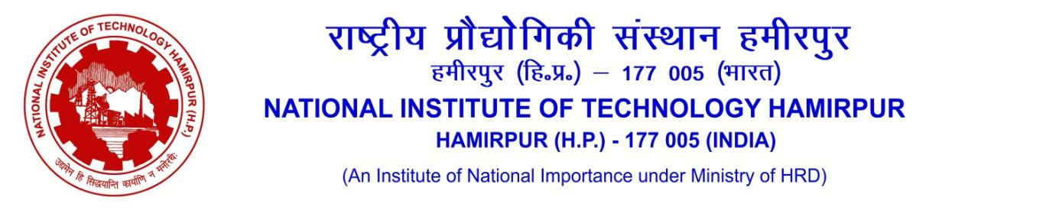
OFFICE OF TRAINING & PLACEMENT
------------------------------------------------------------------------------------------------------------------------------------------------
Job Notification Form/Internship Form
Name of Organization - ________________________________________

Sr. No. | Nature of Drive | Eligible Batches | Specify | No. of likely Vacancies | Remarks
1 | Placement Drive | (UG, PG & PhD) |  |  | Tentative Date of Joining: _______
2 | Internship Drive | - Current (Final Year) Batch B.Tech Students are available for both full time on-line/off-line mode internship up to six months between Jan-June in final semester.  - Current (Final Year) Batch Dual Degree students are available for both full time on-line/off-line mode internship upto six months between Jan-June in final semester.  - Current (Final Year) Batch M.Tech 2nd year students are available for both full time on-line/off-line mode internship initially upto six months, extendable upto 12 months. |  |  | Duration of Internship :  Tentative Start Date:
3 | Both (As mentioned above) | Internship+PPO |  |  | Duration of Internship :  Tentative Start Date:
Note: - Any other internship with or without PPO for B.Tech, Dual Degree, MBA, MSc. students shall only be allowed in online (part time) mode, beyond the routine academic activity hours. No relaxation in academic requirements will be allowed to such students.

1 | Gross Emoluments/ CTC/Pay Package (per annum inclusive of all bonuses) | Placement (Package/PPO): |  |  |  | Internship Stipend:
2 | Job Profile
3 | Eligibility Criteria for students*(For Placement)
4 | Eligibility Criteria for students*(For Internship)
5 | Recruitment Process
 | Mode of Hiring Process | Virtual |  | Onsite
 | Pre-Placement Talk | Yes/No:
 | Written Test | Aptitude |  | Technical
 | Group Discussion | Yes/No
 | Personal Interview | Yes / No
 | Tentative date for conducting Placement/Internship drive | :
 | Tentative date for sharing list of selected candidates | :
6 | No. of persons visiting NIT Hamirpur (If placement drive is to be conducted in onsite mode)
7 | Job Location (Tentative)
8 | Any other specific information:
9 | Contact details of HR | Primary |  |  | Secondary
9 | Name
9 | Mobile Number
9 | Email
*Grading is done on a 10-point scale. NIT Hamirpur has not evolved any formula to convert the CGPI into percentage. However, the CGPI may be notionally converted to percentage by multiplying the CGPI with 10.
Please select (Yes/No) the eligible Programs/Specializations for drive as mentioned below
Sr. No. | Programs Offered | Specializations |  |  | Yes/No
 | B.Tech. disciplines to be considered (4-year course)  (please tick or write yes/no ) | CIRCUITAL BRANCHES
 |  | Computer Science & Engineering
 |  | Mathematics & Computing Engineering (Software Oriented)
 |  | Electronics & Communication Engineering
 |  | Electrical Engineering
 |  | Engineering Physics
 |  | CORE (NON-CIRCUITAL) BRANCHES
 |  | Mechanical Engineering
 |  | Chemical Engineering
 |  | Civil Engineering
 |  | Material Science & Engineering (Metallurgical Engineering)
 | Dual Degree (5-year Course: B.Tech. +M.Tech.) | Computer Science & Engineering
 | Dual Degree (5-year Course: B.Tech. +M.Tech.) | Electronics & Communication Engineering
 | B.Arch. (5-year Course) | Architecture
 | M. Arch. (2-year Course) | Sustainable Architecture
 | M.Tech. (2-year Course)  (please tick or write yes/no) | Civil Engineering
 | M.Tech. (2-year Course)  (please tick or write yes/no) |  |  | Environment
 | M.Tech. (2-year Course)  (please tick or write yes/no) |  |  | Geotechnical
 | M.Tech. (2-year Course)  (please tick or write yes/no) |  |  | Structures
 | M.Tech. (2-year Course)  (please tick or write yes/no) |  |  | Transportation
 | M.Tech. (2-year Course)  (please tick or write yes/no) |  |  | Water Resources
 | M.Tech. (2-year Course)  (please tick or write yes/no) | Computer Science & Engineering
 | M.Tech. (2-year Course)  (please tick or write yes/no) |  |  | Computer Science & Engineering (Artificial Intelligence)
 | M.Tech. (2-year Course)  (please tick or write yes/no) |  |  | Computer Science & Engineering
 | M.Tech. (2-year Course)  (please tick or write yes/no) | Centre for Energy Studies
 | M.Tech. (2-year Course)  (please tick or write yes/no) | (a) | Energy Technology
 | M.Tech. (2-year Course)  (please tick or write yes/no) | Chemical Engineering
 | M.Tech. (2-year Course)  (please tick or write yes/no) | (a) |  | Chemical Engineering
 | M.Tech. (2-year Course)  (please tick or write yes/no) | Electrical Engineering
 | M.Tech. (2-year Course)  (please tick or write yes/no) |  |  | Condition Monitoring of Power Apparatus
 | M.Tech. (2-year Course)  (please tick or write yes/no) |  |  | Power System
 | M.Tech. (2-year Course)  (please tick or write yes/no) |  |  | Signal Processing & Control
 | M.Tech. (2-year Course)  (please tick or write yes/no) | Electronics & Communication Engineering
 | M.Tech. (2-year Course)  (please tick or write yes/no) |  |  | Communication Systems & Networks
 | M.Tech. (2-year Course)  (please tick or write yes/no) |  |  | VLSI Design
 | M.Tech. (2-year Course)  (please tick or write yes/no) | Material Science & Engineering
 | M.Tech. (2-year Course)  (please tick or write yes/no) | (a) |  | Material Science & Engineering
 | M.Tech. (2-year Course)  (please tick or write yes/no) | Mechanical Engineering
 | M.Tech. (2-year Course)  (please tick or write yes/no) |  |  | Design
 | M.Tech. (2-year Course)  (please tick or write yes/no) |  |  | Manufacturing
 | M.Tech. (2-year Course)  (please tick or write yes/no) |  |  | Thermal
 | Master of Business Administration | MBA
 | Master of Business Administration | (Marketing Mgmt.|Operations Mgmt.| Financial Mgmt.|HR Mgmt.)
 | M. Sc. Programs  (2-year course) | Chemistry
 | M. Sc. Programs  (2-year course) | Mathematics & Computing
 | M. Sc. Programs  (2-year course) | Physics & Photonics Science

